POSIX PTHREADS
Operating Systems — Student Notes
Multithreading | Synchronization | Mutexes | Semaphores | Deadlocks
Comprehensive reference for OS and Systems Programming students

SECTION 1: Introduction to Threads & Pthreads

1. Introduction to Threads
A thread is the smallest unit of execution within a process. Modern operating systems and applications rely heavily on threads to achieve concurrency, responsiveness, and efficient CPU utilization.

1.1 What Is a Thread?
Thread: A lightweight, independent execution path within a process that shares the process's address space, code, data, and file descriptors.
Process: A heavyweight execution unit with its own address space. Creating a new process (fork) is expensive compared to creating a thread.
Concurrency: The ability to make progress on multiple tasks within overlapping time periods — does not require true parallelism.
Parallelism: Simultaneous execution of multiple threads on multiple CPU cores at the exact same instant.

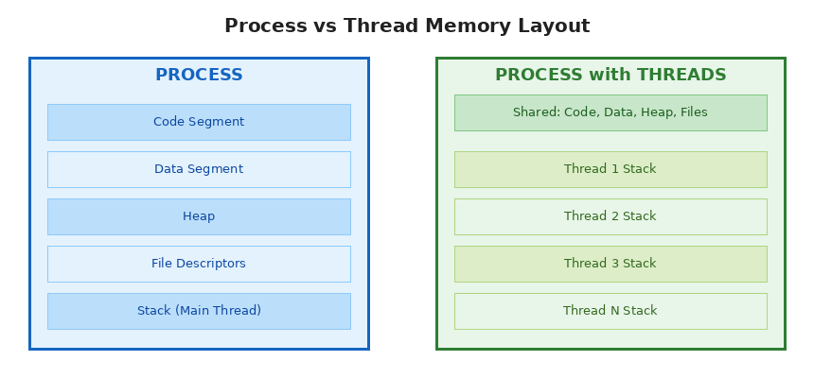
Figure 1.1 – Process vs. Multithreaded Process memory layout

1.2 What Does a Thread Share vs. Own?
Shared Among All Threads | Private to Each Thread
Code (text segment) | Stack (local variables, function call frames)
Global / static data | Registers (program counter, stack pointer)
Heap memory | Thread-local storage (TLS)
File descriptors | Signal mask
Open sockets | Thread ID (TID)
Warning: Because threads share the heap and global data, any unprotected concurrent access leads to data races and undefined behaviour.

1.3 Benefits of Threads
- Responsiveness: One thread handles UI while another does background I/O.
- Resource sharing: Threads share memory without expensive IPC (pipes, sockets).
- Economy: Thread creation and context-switch cost is far lower than process creation.
- Scalability: Programs can exploit multiple cores; a single-threaded process cannot.
- Overlap I/O and computation: While one thread waits for disk/network, others run.

1.4 Challenges of Multithreading
- Data races: Two threads read-modify-write shared data without synchronization.
- Deadlock: Threads waiting indefinitely for resources held by each other.
- Livelock: Threads keep changing state in response to each other but make no progress.
- Starvation: A low-priority thread never gets CPU time.
- Priority inversion: A high-priority thread is blocked by a low-priority thread holding a lock.
- Debugging complexity: Non-deterministic bugs that are hard to reproduce.

2. POSIX (Portable Operating System Interface X - Unix)

Threads (Pthreads) Overview
POSIX Threads (Pthreads) is the standard C API for thread programming on UNIX/Linux/macOS systems. Defined in the IEEE POSIX 1003.1c standard, it provides a portable, powerful threading model.

2.1 Pthreads at a Glance
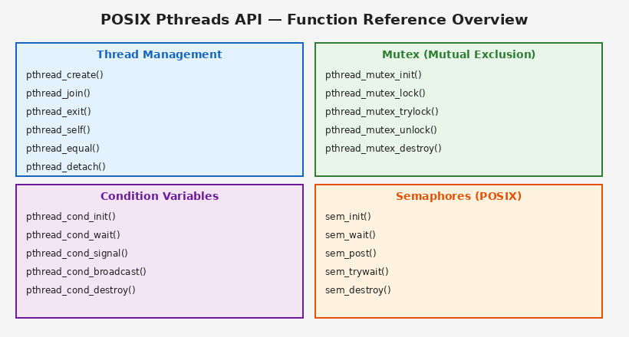
Figure 2.1 – Pthreads API Function Categories
Item | Detail
Header file | #include <pthread.h>
Compile flag | gcc program.c -o program -lpthread
Thread ID type | pthread_t
Mutex type | pthread_mutex_t
Condition variable type | pthread_cond_t
Attribute type | pthread_attr_t
Return value convention | 0 on success; non-zero error code on failure

2.2 Thread States
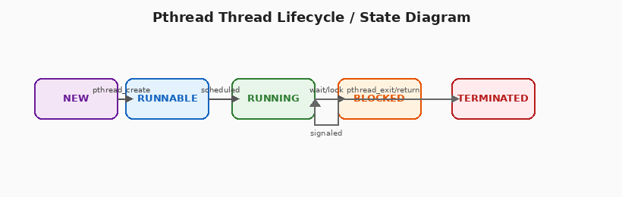
Figure 2.2 – Pthread Thread State Diagram
NEW: Thread created with pthread_create() but not yet scheduled.
RUNNABLE: Ready to run; waiting for CPU assignment by the OS scheduler.
RUNNING: Currently executing on a CPU core.
BLOCKED: Waiting for I/O, a mutex lock, or a condition variable signal.
TERMINATED: Execution complete (returned from start function or called pthread_exit()); resources freed after pthread_join().

SECTION 2: Thread Management

3. Thread Creation and Joining

3.1 pthread_create()
Creates a new thread. The new thread begins executing the specified start_routine with the given argument.
// Signature: pthread_create()
int pthread_create(
pthread_t *thread, // OUTPUT: thread ID stored here
const pthread_attr_t *attr, // thread attributes (NULL = defaults)
void *(*start_routine)(void*), // function the thread will execute
void *arg // argument passed to start_routine
);

// Returns: 0 on success, error code on failure (EAGAIN, EINVAL, EPERM)

Parameter Details
thread: Pointer to a pthread_t variable; the function fills it with the new thread's ID.
attr: Pointer to a pthread_attr_t for stack size, scheduling policy, etc. Pass NULL for defaults.
start_routine: The function the thread executes. Must have signature: void* func(void* arg).
arg: A single void* argument passed to start_routine. Cast to the correct type inside the function. Pass NULL if not needed.

3.2 pthread_join()
Waits for a specific thread to finish and retrieves its exit status. Similar to wait() for child processes.
// Signature: pthread_join()
int pthread_join(
pthread_t thread, // ID of thread to wait for
void **retval // OUTPUT: receives the thread's return value (or NULL)
);

// Blocks the calling thread until "thread" terminates.
// Returns: 0 on success.

Warning: Only joinable threads can be joined. A thread joined more than once, or a detached thread, returns EINVAL.

3.3 pthread_exit()
Terminates the calling thread and optionally passes a return value to a waiting pthread_join().
// Signature: pthread_exit()
void pthread_exit(void *retval);

// retval is passed back to pthread_join()'s second argument.
// Returning from start_routine is equivalent to calling pthread_exit(return_value).

3.4 pthread_self() and pthread_equal()
// Thread identity functions
pthread_t pthread_self(void);
// Returns the calling thread's own ID.

int pthread_equal(pthread_t t1, pthread_t t2);
// Returns non-zero if t1 == t2, 0 otherwise.
// Use this instead of == because pthread_t may be a struct on some systems.

3.5 Detached vs. Joinable Threads
Attribute | Joinable vs Detached
Default state | Joinable — must call pthread_join() | Detached — auto-freed on exit
Can be joined? | Yes — collects exit status | No — resources freed automatically
Memory released | Only after pthread_join() called | Immediately when thread terminates
Use case | Need result or sync termination | Fire-and-forget background tasks
How to create | Default (NULL attrs) | pthread_attr_setdetachstate() or pthread_detach()
Note: A joinable thread that is never joined leaks resources (similar to a zombie process). Always either join or detach every thread.

3.6 Complete Thread Creation Example
// Example: Creating and joining 4 threads
#include <stdio.h>
#include <stdlib.h>
#include <pthread.h>

// Thread function: receives an int* argument
void* thread_func(void *arg) {
int id = *((int*)arg);
printf("Thread %d is running\n", id);
pthread_exit(NULL); // or: return NULL;
}

int main() {
pthread_t tid[4];
int ids[4];

for (int i = 0; i < 4; i++) {
ids[i] = i;
if (pthread_create(&tid[i], NULL, thread_func, &ids[i]) != 0) {
perror("pthread_create failed");
exit(1);
}
}

// Wait for all threads to finish
for (int i = 0; i < 4; i++)
pthread_join(tid[i], NULL);

printf("All threads completed.\n");
return 0;
}

Tip: Compile with: gcc -Wall -o threads threads.c -lpthread

3.7 Thread Attributes (pthread_attr_t)
Function | Purpose
pthread_attr_init(attr) | Initialize attribute object with default values
pthread_attr_destroy(attr) | Free resources used by attribute object
pthread_attr_setdetachstate() | Set PTHREAD_CREATE_JOINABLE or PTHREAD_CREATE_DETACHED
pthread_attr_setstacksize() | Set thread stack size in bytes (minimum ~16 KB)
pthread_attr_setschedpolicy() | Set scheduling policy: SCHED_FIFO, SCHED_RR, SCHED_OTHER
pthread_attr_setschedparam() | Set scheduling priority (for FIFO/RR policies)

SECTION 3: Synchronization — Mutexes

4. Mutexes (Mutual Exclusion Locks)
A mutex is a synchronization primitive that allows only one thread to hold the lock at a time. It protects critical sections — code that accesses shared resources.
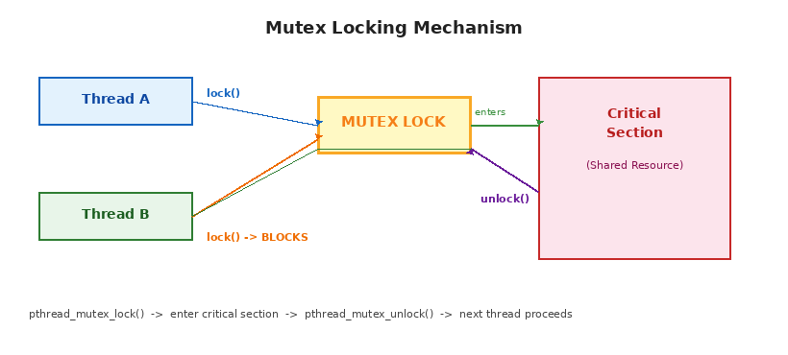
Figure 4.1 – Mutex locking: Thread A holds the lock, Thread B blocks

4.1 The Critical Section Problem
A critical section is any code segment that accesses a shared resource (variable, data structure, file) that must not be executed by more than one thread concurrently.

Three Requirements for a Correct Solution
- Mutual Exclusion: Only one thread in the critical section at a time.
- Progress: If no thread is in the critical section, a waiting thread can enter without infinite delay.
- Bounded Waiting: There is a limit on how many times other threads can enter before a waiting thread is allowed in.

4.2 Mutex API
Function / Macro | Description
pthread_mutex_init(mutex, attr) | Initialize a mutex. Pass NULL for default attributes.
pthread_mutex_lock(mutex) | Acquire the lock. Blocks if already held by another thread.
pthread_mutex_trylock(mutex) | Non-blocking lock attempt. Returns EBUSY if already held.
pthread_mutex_unlock(mutex) | Release the lock. Only the thread that locked it should unlock it.
pthread_mutex_destroy(mutex) | Destroy the mutex, freeing resources. Must be unlocked first.
PTHREAD_MUTEX_INITIALIZER | Static compile-time initializer for global mutexes.

4.3 Mutex Usage Example
// Example: Mutex protecting a shared counter
#include <pthread.h>
#include <stdio.h>

int counter = 0; // shared variable
pthread_mutex_t lock; // mutex declaration

void* increment(void *arg) {
for (int i = 0; i < 100000; i++) {
pthread_mutex_lock(&lock); // ENTER critical section
counter++; // safe: only one thread at a time
pthread_mutex_unlock(&lock); // EXIT critical section
}
return NULL;
}

int main() {
pthread_mutex_init(&lock, NULL); // initialize mutex
pthread_t t1, t2;
pthread_create(&t1, NULL, increment, NULL);
pthread_create(&t2, NULL, increment, NULL);
pthread_join(t1, NULL);
pthread_join(t2, NULL);
pthread_mutex_destroy(&lock); // clean up
printf("Final counter: %d\n", counter); // Always 200000
return 0;
}

4.4 Mutex Types
Type | Behaviour
PTHREAD_MUTEX_DEFAULT | Standard mutex. Re-locking by the same thread causes undefined behaviour.
PTHREAD_MUTEX_NORMAL | Same as DEFAULT. No error checking. Fastest.
PTHREAD_MUTEX_ERRORCHECK | Returns an error if same thread tries to lock again (EDEADLK).
PTHREAD_MUTEX_RECURSIVE | Same thread can lock multiple times. Must unlock equal number of times. Useful for recursive functions.
// Setting mutex type via attributes
pthread_mutexattr_t attr;
pthread_mutexattr_init(&attr);
pthread_mutexattr_settype(&attr, PTHREAD_MUTEX_RECURSIVE);
pthread_mutex_init(&my_mutex, &attr);
pthread_mutexattr_destroy(&attr);

4.5 Best Practices for Mutexes
- Always unlock in the same function that locked — avoid complex lock/unlock paths.
- Minimize time spent inside the critical section to reduce contention.
- Never call blocking functions (sleep, I/O) while holding a lock.
- Use consistent lock ordering when multiple mutexes are needed to prevent deadlock.
- Consider RAII-style wrappers in C++ (std::lock_guard) to guarantee unlock on exceptions.
- Prefer trylock with timeout patterns in time-critical code instead of blocking lock.

SECTION 4: Condition Variables

5. Condition Variables
A condition variable allows threads to suspend execution and give up the CPU until some condition becomes true. It must always be used together with a mutex.
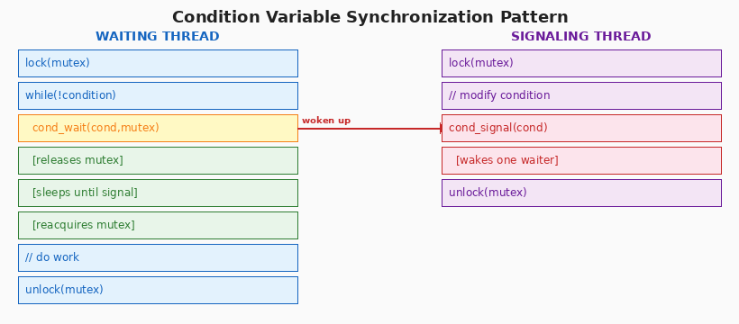
Figure 5.1 – Condition Variable: waiting and signaling pattern

5.1 Why Condition Variables?
Busy-waiting (spinning in a loop checking a condition) wastes CPU cycles. Condition variables solve this by putting the waiting thread to sleep until the condition changes.
// Busy-wait vs condition variable
// BAD: busy-waiting wastes CPU
while (queue_empty) { /* spin */ } // 100% CPU usage doing nothing

// GOOD: condition variable — thread sleeps until signaled
pthread_mutex_lock(&mutex);
while (queue_empty) // always use while, not if
pthread_cond_wait(&cond, &mutex);
// work with shared resource...
pthread_mutex_unlock(&mutex);

5.2 Condition Variable API
Function / Macro | Description
pthread_cond_init(cond, attr) | Initialize a condition variable.
pthread_cond_wait(cond, mutex) | Atomically: releases mutex and blocks on cond. When woken, reacquires mutex.
pthread_cond_timedwait(cond,mutex,t) | Like cond_wait but returns ETIMEDOUT if time t elapses.
pthread_cond_signal(cond) | Wake ONE thread waiting on cond.
pthread_cond_broadcast(cond) | Wake ALL threads waiting on cond.
pthread_cond_destroy(cond) | Destroy the condition variable. No threads should be waiting.
PTHREAD_COND_INITIALIZER | Static compile-time initializer for global condition variables.
Note: pthread_cond_wait() atomically releases the mutex and suspends the thread. Upon return it re-holds the mutex. This is why mutex and condition variable are always paired.

5.3 Why While Loop, Not If?
Spurious wakeups are allowed by the POSIX standard — a thread may wake up from cond_wait without being signaled. Always re-check the condition in a while loop:
// Always use while loop with cond_wait
// CORRECT pattern
pthread_mutex_lock(&mutex);
while (!condition_is_true) { // re-check after every wakeup
pthread_cond_wait(&cond, &mutex);
}
// condition is now guaranteed true here
pthread_mutex_unlock(&mutex);

// WRONG pattern (vulnerable to spurious wakeups)
pthread_mutex_lock(&mutex);
if (!condition_is_true) { // only checks once!
pthread_cond_wait(&cond, &mutex);
}
// condition might NOT be true here!
pthread_mutex_unlock(&mutex);

5.4 signal() vs broadcast()
Function | When to Use
pthread_cond_signal() | Wakes exactly ONE waiting thread. Use when only one thread needs to act on the change (e.g., producer-consumer with one item available).
pthread_cond_broadcast() | Wakes ALL waiting threads. Use when ALL threads might need to re-evaluate the condition (e.g., resize event, global flag change).
Warning: Signaling without holding the mutex is technically allowed but can cause missed signals. Always hold the mutex when calling signal() or broadcast().

5.5 Full Producer-Consumer Example
// Producer-Consumer with Condition Variables
#define BUFFER_SIZE 5
int buffer[BUFFER_SIZE], count = 0;
pthread_mutex_t mutex = PTHREAD_MUTEX_INITIALIZER;
pthread_cond_t not_full = PTHREAD_COND_INITIALIZER;
pthread_cond_t not_empty = PTHREAD_COND_INITIALIZER;

void* producer(void *arg) {
while (1) {
int item = produce_item();
pthread_mutex_lock(&mutex);
while (count == BUFFER_SIZE) // buffer full: wait
pthread_cond_wait(&not_full, &mutex);
buffer[count++] = item; // add to buffer
pthread_cond_signal(&not_empty); // notify consumer
pthread_mutex_unlock(&mutex);
}
}

void* consumer(void *arg) {
while (1) {
pthread_mutex_lock(&mutex);
while (count == 0) // buffer empty: wait
pthread_cond_wait(&not_empty, &mutex);
int item = buffer[--count]; // take from buffer
pthread_cond_signal(&not_full); // notify producer
pthread_mutex_unlock(&mutex);
consume_item(item);
}
}

SECTION 5: POSIX Semaphores

6. Semaphores
A semaphore is a non-negative integer counter used for signaling between threads (and processes). Unlike mutexes, semaphores can be signaled from a different thread than the one that waited — making them suitable for event signaling.
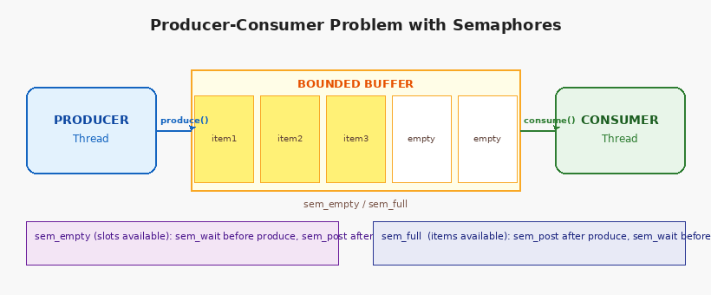
Figure 6.1 – Producer-Consumer with Semaphore flow

6.1 Semaphore Types
Type | Description
Binary Semaphore | Value is 0 or 1. Behaves similarly to a mutex. Used for mutual exclusion.
Counting Semaphore | Value >= 0. Counts available resources. Used for bounded buffers, resource pools.
Named Semaphore | Identified by a filesystem name (sem_open). Can be shared between processes.
Unnamed Semaphore | Lives in memory (sem_init). Can be shared between threads or related processes via shared memory.

6.2 POSIX Semaphore API
Function / Item | Description
#include <semaphore.h> | Required header
sem_init(sem, pshared, value) | Initialize: pshared=0 for threads, 1 for processes; value=initial count.
sem_wait(sem) | Decrement (P operation). Blocks if value is 0.
sem_trywait(sem) | Non-blocking sem_wait. Returns EAGAIN if value is 0.
sem_timedwait(sem, abstime) | Blocking wait with absolute timeout.
sem_post(sem) | Increment (V operation). Wakes a blocked thread if any.
sem_getvalue(sem, val) | Read current semaphore value into *val.
sem_destroy(sem) | Destroy an unnamed semaphore.

6.3 Semaphore Operations: P and V
Semaphores are defined by two atomic operations originally named P (Dutch: proberen = try) and V (Dutch: verhogen = increase):
Operation | Behaviour
P / wait / down / sem_wait() | Decrement the counter. If counter becomes negative, the calling thread blocks until another thread performs V.
V / signal / up / sem_post() | Increment the counter. If one or more threads are blocked on P, wake one of them.
// Basic semaphore usage
sem_t sem;
sem_init(&sem, 0, 3); // 3 resources initially available

void* worker(void *arg) {
sem_wait(&sem); // acquire a resource (P)
// ... use the resource ...
sem_post(&sem); // release the resource (V)
return NULL;
}

6.4 Mutex vs Semaphore — Key Differences
Aspect | Mutex vs Semaphore
Ownership | Mutex: only locking thread can unlock | Semaphore: any thread can post (V)
Purpose | Mutex: mutual exclusion | Semaphore: signaling & resource counting
Initial value | Mutex: unlocked(1) or locked(0) | Semaphore: any non-negative integer
Use across processes? | Mutex: requires shared memory | Semaphore: yes (named or pshared=1)
Deadlock risk | Mutex: yes if ordering wrong | Semaphore: lower, but starvation possible
Performance | Mutex: faster for mutual exclusion | Semaphore: more flexible, slightly heavier

SECTION 6: Deadlocks

7. Deadlocks
A deadlock occurs when two or more threads are permanently blocked, each waiting for a resource held by the other. No thread can make progress.
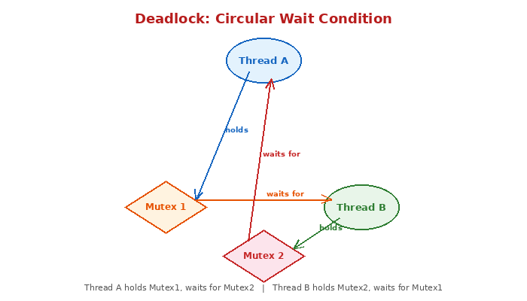
Figure 7.1 – Deadlock: Circular Wait Between Two Threads

7.1 The Four Coffman Conditions
All four conditions must hold simultaneously for a deadlock to occur. Preventing any one breaks the deadlock.
- Mutual Exclusion: At least one resource must be non-shareable — only one thread can use it at a time.
- Hold and Wait: A thread holds at least one resource while waiting to acquire additional resources held by other threads.
- No Preemption: Resources cannot be forcibly taken from a thread; they must be released voluntarily.
- Circular Wait: A circular chain of threads exists where each thread holds a resource that the next thread in the chain is waiting for.
Warning: If even one of the four conditions is eliminated, deadlock cannot occur. Most prevention strategies target Circular Wait or Hold-and-Wait.

7.2 Deadlock Example in Code
// Classic deadlock: inconsistent lock ordering
pthread_mutex_t mutex_A, mutex_B;

void* thread_one(void *arg) {
pthread_mutex_lock(&mutex_A); // holds A
sleep(1); // gives thread_two time to lock B
pthread_mutex_lock(&mutex_B); // DEADLOCK: waits for B (held by thread_two)
/* work */
pthread_mutex_unlock(&mutex_B);
pthread_mutex_unlock(&mutex_A);
return NULL;
}

void* thread_two(void *arg) {
pthread_mutex_lock(&mutex_B); // holds B
sleep(1);
pthread_mutex_lock(&mutex_A); // DEADLOCK: waits for A (held by thread_one)
/* work */
pthread_mutex_unlock(&mutex_A);
pthread_mutex_unlock(&mutex_B);
return NULL;
}

7.3 Deadlock Prevention Strategies
Strategy | Description
Lock Ordering | Assign a global order to all mutexes. Every thread must always lock in that order. Eliminates Circular Wait.
Lock Hierarchy | Number mutexes (1, 2, 3...). Always acquire lower-numbered locks first.
Try-Lock with Backoff | Use pthread_mutex_trylock(). If it fails, release all held locks and retry after a random delay.
Lock All at Once | Use pthread_mutex_lock() on all needed mutexes before holding any. Eliminates Hold-and-Wait.
Timeout | Use pthread_mutex_timedlock(). If lock not acquired within time limit, abort and retry.

7.4 Fixed Deadlock: Consistent Lock Order
// Deadlock prevention: consistent lock ordering
// FIX: both threads acquire locks in the SAME order (A before B)
void* thread_one(void *arg) {
pthread_mutex_lock(&mutex_A);
pthread_mutex_lock(&mutex_B);
/* work */
pthread_mutex_unlock(&mutex_B);
pthread_mutex_unlock(&mutex_A);
return NULL;
}

void* thread_two(void *arg) {
pthread_mutex_lock(&mutex_A); // same order: A first
pthread_mutex_lock(&mutex_B);
/* work */
pthread_mutex_unlock(&mutex_B);
pthread_mutex_unlock(&mutex_A);
return NULL;
}

SECTION 7: Advanced Pthreads Topics

8. Thread-Specific Data (TLS)
Thread-Local Storage allows each thread to have its own private copy of a variable, without synchronization. Useful for per-thread state such as error codes, buffers, or context objects.

8.1 TLS API
Function | Description
pthread_key_create(key, destructor) | Create a TLS key. The destructor is called when a thread exits with non-NULL TLS value.
pthread_key_delete(key) | Delete the TLS key (does not call destructor).
pthread_setspecific(key, value) | Set the calling thread's value for the given key.
pthread_getspecific(key) | Get the calling thread's value for the given key (returns void*).
// Thread-Specific Data example
pthread_key_t tls_key;

void cleanup(void *val) { free(val); } // called on thread exit

void* thread_func(void *arg) {
int *my_data = malloc(sizeof(int));
*my_data = pthread_self(); // unique per thread
pthread_setspecific(tls_key, my_data);

int *retrieved = pthread_getspecific(tls_key);
printf("My data: %d\n", *retrieved);
return NULL; // cleanup() called automatically
}

int main() {
pthread_key_create(&tls_key, cleanup);
// create threads...
pthread_key_delete(tls_key);
return 0;
}

Tip: In C11 and later, you can use the _Thread_local storage class specifier for simpler TLS: _Thread_local int my_var = 0;

9. Read-Write Locks
A read-write lock (rwlock) allows multiple readers simultaneously but only one writer at a time. Ideal when reads are frequent and writes are rare.
Function | Description
pthread_rwlock_init(rwlock, attr) | Initialize the rwlock.
pthread_rwlock_rdlock(rwlock) | Acquire read lock. Multiple readers can hold it simultaneously.
pthread_rwlock_wrlock(rwlock) | Acquire write lock. Exclusive — blocks until all readers release.
pthread_rwlock_tryrdlock(rwlock) | Non-blocking rdlock attempt.
pthread_rwlock_trywrlock(rwlock) | Non-blocking wrlock attempt.
pthread_rwlock_unlock(rwlock) | Release either read or write lock.
pthread_rwlock_destroy(rwlock) | Destroy the rwlock.
// Read-Write Lock example
pthread_rwlock_t rwlock = PTHREAD_RWLOCK_INITIALIZER;
int shared_data = 0;

void* reader(void *arg) {
pthread_rwlock_rdlock(&rwlock); // many readers can enter
printf("Read: %d\n", shared_data);
pthread_rwlock_unlock(&rwlock);
return NULL;
}

void* writer(void *arg) {
pthread_rwlock_wrlock(&rwlock); // exclusive write access
shared_data++;
pthread_rwlock_unlock(&rwlock);
return NULL;
}

10. Barriers
A barrier synchronizes a set of threads at a meeting point: no thread can proceed past the barrier until ALL threads in the group have reached it.
// Barrier synchronization
pthread_barrier_t barrier;

int main() {
int N = 4;
pthread_barrier_init(&barrier, NULL, N); // require N threads to arrive
// create N threads, each calls barrier_wait...
pthread_barrier_destroy(&barrier);
}

void* worker(void *arg) {
printf("Phase 1 work\n");
pthread_barrier_wait(&barrier); // ALL threads must reach here
printf("Phase 2 work\n"); // only starts after all finish Phase 1
return NULL;
}

Note: Barriers are ideal for parallel algorithms with phases: e.g., parallel matrix multiplication where all threads must complete row computation before column operations begin.

SECTION 8: Common Errors, Debugging & Best Practices

11. Common Pthreads Errors
Error | Cause & Fix
Data Race | Two threads access the same memory concurrently; at least one writes without synchronization. Use mutex or atomic operations.
Deadlock | Circular waiting for mutexes. Fix: consistent lock ordering, trylock with backoff.
Forgotten join/detach | Joinable thread never joined — memory and resource leak. Always join or detach.
Unlock by wrong thread | Thread B unlocks a mutex locked by Thread A — undefined behaviour. Only the owning thread may unlock.
Condition variable misuse | Using if instead of while with cond_wait — vulnerable to spurious wakeups.
Stack variable address passed as arg | pthread_create(&t,NULL,fn,&local_var) — local_var may go out of scope before thread uses it. Use heap allocation.
Double lock (non-recursive mutex) | Same thread locking a normal mutex twice — instant deadlock. Use PTHREAD_MUTEX_RECURSIVE if needed.
Forgetting -lpthread | Linker error at compile time. Always compile with gcc ... -lpthread.

11.1 Debugging Multithreaded Programs

Valgrind Helgrind (Data Race Detector)
# Detect data races with Helgrind
valgrind --tool=helgrind ./my_program
# Reports: data races, lock ordering violations, misuse of pthreads API

ThreadSanitizer (TSan)
# Detect races with ThreadSanitizer
gcc -fsanitize=thread -g ./my_program.c -o my_program -lpthread
./my_program
# TSan instruments memory accesses at compile time; very fast race detection

GDB Thread Commands
GDB Command | Purpose
info threads | List all threads and their current locations
thread N | Switch to thread N
thread apply all bt | Print backtrace for all threads
set scheduler-locking on | Only advance the current thread when stepping
watch -l var | Watchpoint: break when var changes

11.2 Pthreads Best Practices Summary
- Always initialize mutexes and condition variables before use.
- Always destroy synchronization objects when done.
- Keep critical sections as short as possible.
- Avoid calling blocking or sleeping functions while holding a mutex.
- Use while (not if) with pthread_cond_wait().
- Establish and strictly follow a global mutex lock order.
- Check return values of all pthread functions during development.
- Pass heap-allocated data to threads; never pass stack-local variable addresses.
- Every joinable thread must be joined; every thread that will not be joined must be detached.
- Prefer condition variables over busy-waiting for event signaling.

SECTION 9: Quick Reference Cheat Sheet

12. Pthreads Quick Reference

Thread Management
Call | Action
pthread_create(&tid, NULL, fn, arg) | Create thread executing fn(arg)
pthread_join(tid, NULL) | Wait for thread to finish
pthread_exit(retval) | Terminate calling thread
pthread_self() | Get calling thread's ID
pthread_equal(t1,t2) | Compare two thread IDs
pthread_detach(tid) | Mark thread as detached

Mutex Quick Reference
Call | Action
pthread_mutex_t m = PTHREAD_MUTEX_INITIALIZER; | Static init
pthread_mutex_init(&m, NULL) | Dynamic init
pthread_mutex_lock(&m) | Acquire (blocking)
pthread_mutex_trylock(&m) | Acquire (non-blocking)
pthread_mutex_unlock(&m) | Release
pthread_mutex_destroy(&m) | Cleanup

Condition Variable Quick Reference
Call | Action
pthread_cond_t c = PTHREAD_COND_INITIALIZER; | Static init
pthread_cond_init(&c, NULL) | Dynamic init
pthread_cond_wait(&c, &m) | Release mutex & sleep
pthread_cond_signal(&c) | Wake one waiter
pthread_cond_broadcast(&c) | Wake all waiters
pthread_cond_destroy(&c) | Cleanup

Semaphore Quick Reference
Call | Action
#include <semaphore.h> | Required header
sem_init(&s, 0, N) | Init with value N (thread-shared)
sem_wait(&s) | Decrement / P operation (block if 0)
sem_trywait(&s) | Non-blocking sem_wait
sem_post(&s) | Increment / V operation
sem_destroy(&s) | Cleanup

Compilation
# Compile commands
# Basic compilation
gcc -Wall -Wextra -g program.c -o program -lpthread

# With ThreadSanitizer for race detection
gcc -Wall -g -fsanitize=thread program.c -o program -lpthread

# With AddressSanitizer (catches heap issues too)
gcc -Wall -g -fsanitize=address,undefined program.c -o program -lpthread

13. Glossary
Atomic Operation: An operation that completes in a single step with respect to other threads — no thread can observe it in a partial state.
Barrier: A synchronization point where all threads in a group must arrive before any can proceed.
Busy-Waiting (Spin-Wait): Continuously checking a condition in a loop while consuming CPU time. Inefficient; prefer condition variables.
Condition Variable: A synchronization object that allows threads to sleep until notified that a condition has changed.
Concurrency: Overlapping execution of multiple tasks; does not require simultaneous execution on multiple cores.
Critical Section: A code region that accesses shared resources and must not be executed concurrently by multiple threads.
Data Race: Concurrent unsynchronized access to shared data where at least one access is a write.
Deadlock: A state where two or more threads are permanently blocked, each waiting for a resource held by the other.
Detached Thread: A thread whose resources are automatically freed when it terminates; cannot be joined.
Joinable Thread: A thread whose exit status can be collected by another thread via pthread_join().
Livelock: Threads actively change state in response to each other but neither makes progress.
Mutex: A mutual exclusion lock that allows only one thread to hold it at a time.
Parallelism: Simultaneous execution of multiple threads on multiple CPU cores.
POSIX: Portable Operating System Interface — a family of standards for UNIX-like operating systems.
Priority Inversion: A high-priority thread is blocked by a low-priority thread holding a required lock.
pthreads: POSIX Threads — the standard C API for multithreading on UNIX/Linux systems.
Race Condition: A bug where program behavior depends on the relative timing of thread execution.
Read-Write Lock: Allows multiple concurrent readers or one exclusive writer.
Semaphore: A non-negative integer counter used for signaling and resource counting between threads.
Spinlock: A lock where the waiting thread repeatedly checks (spins) until the lock is available; uses CPU but avoids context-switch overhead for very short waits.
Spurious Wakeup: A thread waking from cond_wait without being signaled — allowed by POSIX. Always re-check condition in a while loop.
Starvation: A thread that never gets CPU time or resource access due to other threads continuously taking priority.
Thread: A lightweight execution unit within a process that shares the process's address space.
Thread-Local Storage (TLS): Per-thread private storage not shared with other threads.
Thread Pool: A set of pre-created worker threads that pick up tasks from a queue, avoiding thread creation overhead.

